Título del Proyecto | POSITION-II “A pilot line for the next generation of smart catheters and implants”
Nº de expediente asignado | GA: 783132
Abstract | In POSITION a pilot line for the realization of the next generation of smart catheters and implants will be established. In this pilot line scalable open technology platforms based on essential technologies contributed by many European companies will be integrated in one manufacturing network. POSITION will enable the electronic industry to take the lead in the development of these live saving instruments. The next generation smart catheters and implants developed in POSITION will:  - Use open platform technologies accessible to multiple end-users that are steered by roadmaps enabling end-users to focus on their applications;  - Bring digitization at the tip to reduce wires and thus assembly cost and pave the way towards standardization and wireless connectivity to “unclutter” the cath lab;  - Enable a better diagnosis by using state of the art sensors and (ultra-sound) MEMS devices, and signal processing directly at the tip of the instrument;  - Streamline the work-flow in the cath lab, resulting in a more intuitive work environment for the surgeon, resulting in less errors and a more efficient workflow
Entidad Financiadora | Electronic Component Systems for European Leadership Joint Undertaking (JU) - ECSEL JU
Convocatoria: | H2020-ECSEL-2017-1-IA-two-stage
Importe de la ayuda | 437.500€ (153.500€ JU + otros financiadores)
Fechas de ejecución del proyecto | 01/06/2018-31/05/2021
 | POSITION-II has received funding within the Electronic Components and Systems for European Leadership Joint Undertaking (ECSEL JU) in collaboration with the European Union's H2020 Framework Programme (H2020/2014-2020) and National Authorities, under grant agreement Ecsel-783132-Position-II-2017-IA
 | 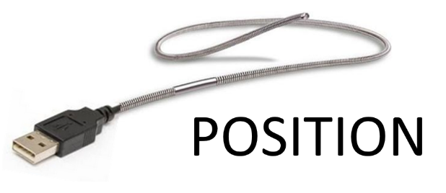
Enlaces: | http://position-2.eu/

